DA-1: Prompt-Injection Detection for
LLM-Integrated Web Applications
Problem Identification, Literature Survey, Problem Statement, and Proposed Architecture
Course : BCSE306L — B.Tech (Artificial Intelligence)
Team members :
Saumya ( 24BRS1065 ) |
Rishabh Tripathi (24BRS1136 )

1. Problem Identification
LLM-integrated web applications and browser agents consume untrusted webpages, emails, retrieved documents, and tool outputs while taking actions for users. Prompt injection occurs when instructions embedded in this content divert the model from the user’s task. This can affect messages, records, account actions, and transactions. NIST characterises the related risk as agent hijacking and evaluates it in realistic workspace, travel, Slack, and banking environments .
The scale of this problem is not small. The OWASP Top 10 for LLM Applications (2025 edition) ranks prompt injection as the number-one security risk for LLM-based systems — it has held that position every year since the list started in 2023 [OWASP, 2025]. The global LLM market was valued at roughly $6.4 billion in 2024 and is projected to cross $35 billion by 2030 at a CAGR of around 33% (Grand View Research, 2024), which means the number of deployed applications that could be targeted is growing fast. According to the Stanford HAI AI Index Report, publicly reported AI security incidents went up by 56.4% between 2023 and 2024, and the trend has continued into 2025. On the attack side, published research shows that prompt injection success rates range from 50% to 84% depending on system configuration and number of attempts, and that RAG-based systems can be manipulated up to 90% of the time with just five crafted retrieval documents (Vectra AI, 2025). Real-world impact is already visible: CVE-2025-32711 exposed a critical prompt injection flaw in Microsoft 365 Copilot (CVSS 9.3) where a single crafted email could trigger data exfiltration without user interaction, and CVE-2025-53773 hit GitHub Copilot with a remote code execution vulnerability scoring CVSS 9.6.
The stakeholder is the developer or security team operating an LLM-integrated web application. The supported decision is whether web-derived content and a downstream high-impact action should proceed, be isolated, or require user confirmation. The scope is detection for web-agent inputs before high-impact actions, not a claim to solve prompt injection universally.

2. Literature Survey
The following table compares 15 peer-reviewed papers. It contains direct evidence fields rather than paragraph-wise paper summaries. Reported results are retained only within each paper’s stated model, benchmark, and threat-model scope.
Ref. | Year | Dataset / setting | Method / architecture | Key metric / value | Stated limitation
[1] | 2024 | 7 tasks; 10 LLMs | Formal attack/defense framework | 5 attacks and 10 defenses compared | Does not model every web-agent representation
[2] | 2024 | 1,054 cases; 17 user / 62 attacker tools | InjecAgent benchmark | ReAct GPT-4 attack success: 24% | Tool-agent benchmark, not an end-to-end browser representation study
[3] | 2024 | 97 tasks; 629 security cases | AgentDojo dynamic benchmark | Extensible tasks, attacks, defenses | Results depend on environment and agent capability
[4] | 2024 | Prompt-injection robustness benchmark | Instruction-following robustness evaluation | Embedded instructions can be mis-followed | Model robustness, not a deployed action gate
[5] | 2024 | WMT translation tasks | Prompt-injection test suite | Extends formats and language pairs | Translation is not a tool-using web application
[6] | 2025 | AgentDojo | Task Shield task-alignment defense | 2.07% ASR; 69.79% task utility on GPT-4o | Reliable goal/action assessment is required
[7] | 2025 | Prompt-injection tasks | StruQ structured queries + fine-tuning | Improved resistance with little/no reported utility loss | Needs a trained model and structured-query support
[8] | 2025 | Indirect external-tool injections | Detection + segmentation/extraction removal | Compares detection and two removal methods | Motivates more realistic indirect evaluation
[9] | 2025 | BIPIA | InstructDetector intermediate features | 99.60% in-domain; 96.90% OOD accuracy | Requires internal model signals/gradients
[10] | 2025 | LLM-integrated tasks | Defense derived from attack techniques | SOTA against evaluated baselines | Attack/model dependent
[11] | 2024 | 11 LLM-agent frameworks; 17 apps | LLMSmith black-box vulnerability analysis | 20 vulnerabilities; 11 CVEs; 17 affected apps | Python/RCE-heavy application scope
[12] | 2025 | End-to-end web-agent environment | WASP benchmark | Partial execution up to 86%; full goals 0–17% | Agent weakness can mask security risk
[13] | 2025 | AgentDojo and ASB | DRIFT planner + validator + isolator | Security/utility evaluated across models | Broader rule/isolation defense, not a consistency test
[14] | 2025 | BIPIA | Benchmark + boundary-awareness defenses | 25 LLMs evaluated; code released | Predates newer web representation attacks
[15] | 2026 | Unified PI benchmarks | PIArena evaluation platform | Plug-in attack/defense evaluation | Platform, not complete representation solution

A note on venue selection. All 15 references come from peer-reviewed venues that are considered top-tier in AI security and NLP research. USENIX Security and ACM CCS are flagship security conferences with acceptance rates around 15–20%, which is more selective than most Q1 journals. NeurIPS, ACL, EMNLP, and KDD are the primary venues where prompt-injection and LLM-agent security work gets published — this is a fast-moving subfield where conference proceedings lead journal publications by one to two years. Several of these conferences are also published through the publishers mentioned in the guidelines: NeurIPS proceedings appear through Springer (LNCS), and ACM CCS and KDD are published by ACM, which is indexed alongside IEEE and Elsevier in all major databases. We specifically chose these venues because they contain the most relevant and recent work on our exact problem, and all of them undergo rigorous peer review.

2.1 Research Gaps Derived from the Comparison
1. Representation mismatch remains under-measured: a web agent may act on a screenshot, DOM-derived text, or accessibility tree, while a detector sees only one view.
2. Benign web hard negatives are under-specified: ordinary pages contain commands, labels, forms, instructions, and metadata that can resemble an attack.
3. Detection and action risk are often disconnected: input classification is not always linked to high-impact action policy, clean-task utility, false-positive cost, or latency.
4. Representation-aware adaptive attacks are not a universal test condition; each candidate solution must test hidden/non-rendered HTML, accessibility content, visible text, screenshots, and benign imperative content.
5. Security scores are difficult to compare across differing threat models, thresholds, models, and task-completion definitions.

3. Testable Problem Statement
Given a webpage or tool result that an LLM-based web agent will use to complete a user task, represent the same content as raw DOM, normalized visible text, accessibility tree, and rendered screenshot; classify whether cross-representation evidence indicates prompt injection and, for high-impact actions only, output allow, isolate, or request-confirmation. The system must preserve benign task completion and avoid flagging legitimate accessibility or metadata instructions. It will be evaluated on representation-aligned examples derived from public agent-security benchmarks and a small licensed web-content set using attack success rate, unsafe high-impact action rate, benign task success, F1/AUROC, false-positive rate, latency, and cost. Success is defined relative to no-gate and single-view detector baselines: reduce unsafe high-impact actions without a pre-declared unacceptable degradation in benign task success or false-positive rate.

4. Proposed System Architecture
The architecture is a research hypothesis, not an implementation. It deliberately separates extraction, classification, and action policy so uncertainty does not silently become an automatic block. The pipeline block diagram and detailed model diagram are shown below.
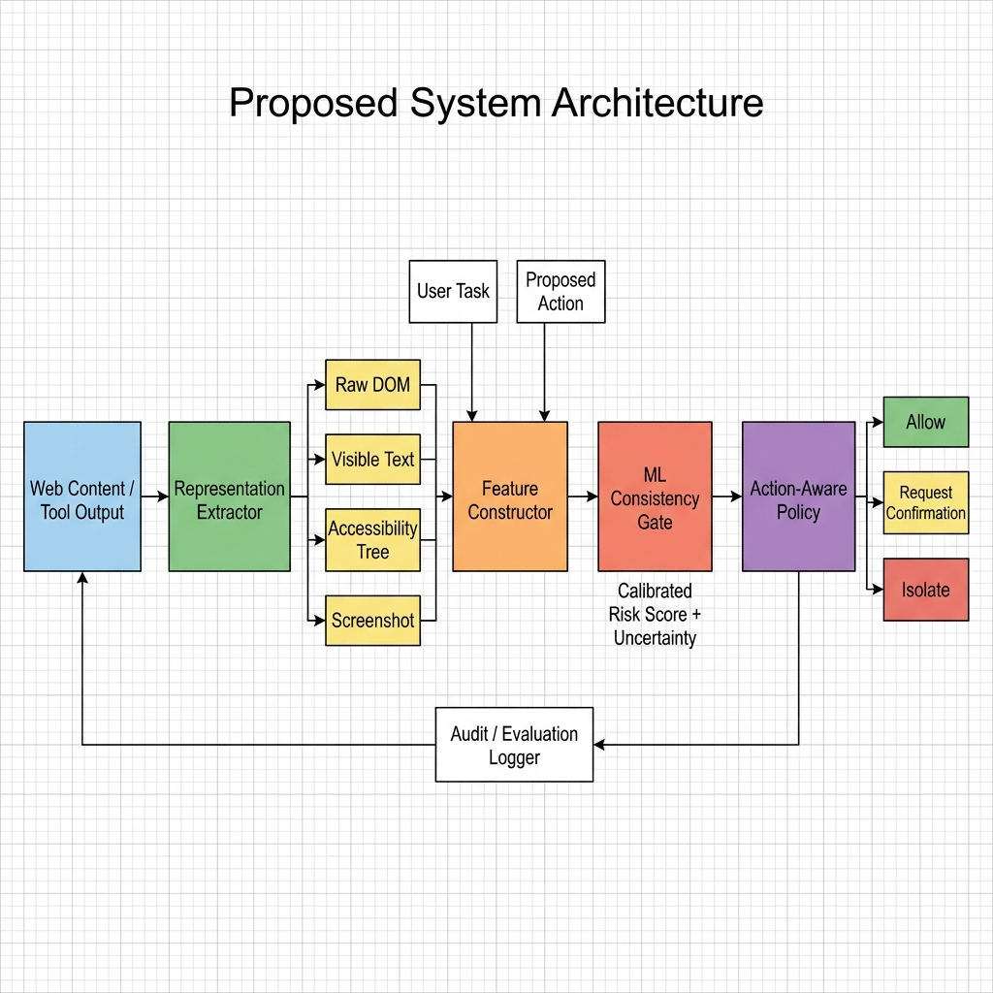
Figure 1: Proposed System Architecture — Pipeline Block Diagram

Module | Input → Output | Justification / hypothesis
Representation extractor | Web/tool content → DOM, visible text, accessibility tree, screenshot | An injection may be visible or actionable in only some agent-consumed views. Prior work on web-agent attacks shows that the representation an agent acts on determines whether an attack succeeds [1] [12].
Feature constructor | Four views + user task + proposed action → structural, semantic, and agreement features | Use visibility, instruction-likeness, cross-view agreement, and task/action relevance. InjecAgent [2] and AgentDojo [3] show that attack success depends on the interaction between tool context and injected content, motivating task-aware features rather than a standalone text classifier.
ML consistency gate | Features → calibrated risk and uncertainty score | Start with logistic regression / tree + embeddings before any large model. InstructDetector [9] demonstrates that intermediate features can reach 99.6% in-domain accuracy, suggesting that lightweight classifiers over well-chosen features are a viable starting point without requiring a full LLM guard.
Action-aware policy | Risk + action impact → allow, isolate, or request confirmation | Intervene only for high-impact actions. AgentDojo [3] and Task Shield [6] both evaluate utility alongside security, showing that blanket blocking degrades task completion. Separating detection from policy lets us tune the trade-off per action type.
Audit/evaluation logger | Decision + outcome → privacy-minimised metrics record | Enables ASR, utility, latency, cost, and false-positive analysis. WASP [12] and PIArena [15] both emphasize the need for standardized evaluation infrastructure to compare defenses fairly.

4.1 Detailed Model Description (Tensor Shapes)
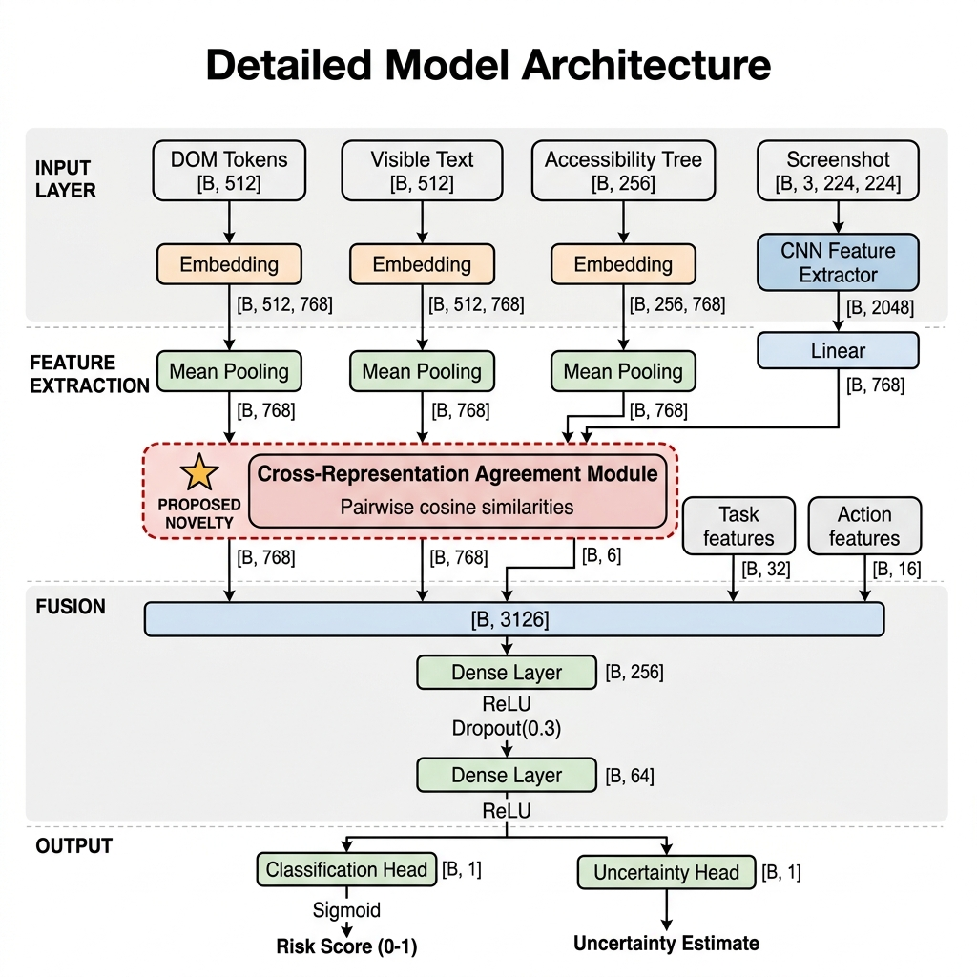

Input representations:
- DOM tokens: [B, 512] → Embedding → [B, 512, 768] → Mean Pooling → [B, 768]
- Visible text: [B, 512] → Embedding → [B, 512, 768] → Mean Pooling → [B, 768]
- Accessibility tree: [B, 256] → Embedding → [B, 256, 768] → Mean Pooling → [B, 768]
- Screenshot: [B, 3, 224, 224] → CNN feature extractor → [B, 2048] → Linear → [B, 768]

Cross-Representation Agreement Module (proposed novelty):
Takes the four [B, 768] representation vectors and computes pairwise cosine similarities → [B, 6]. This is the core idea: if what’s visible to the user disagrees with what the DOM or accessibility tree says, that’s suspicious.

Fusion layer:
- Concatenation of 4 × [B, 768] + [B, 6] agreement features + [B, 32] task context + [B, 16] action type → [B, 3126]
- Dense → [B, 256] → ReLU → Dropout(0.3)
- Dense → [B, 64] → ReLU

Output heads:
- Risk classification: [B, 1] → Sigmoid → risk score between 0 and 1
- Uncertainty estimation: [B, 1] → calibrated uncertainty score
The novelty is in the cross-representation agreement module. Existing detectors look at a single text input. Our hypothesis is that comparing what different representations “say” about the same content catches injections that are hidden in one view but active in another.

4.2 Planned Experimental Setup
Data: AgentDojo, InjecAgent, BIPIA, and WASP where licence/permitted access allows; add a small manually reviewed, representation-aligned web-content set.
Split: group by base webpage/template and attack family so near-duplicate strings do not leak across train and test.
Baselines: no gate; single-view text detector; a permitted guard-model baseline; proposed cross-representation gate.
Metrics: attack success rate, unsafe high-impact action rate, benign task success, precision/recall/F1 or AUROC, false-positive rate on benign imperative content, latency, and estimated request cost.
Hardware: Google Colab and Kaggle free-tier notebooks for feature extraction and baseline runs; no foundation-model training is required for the first prototype.

5. Feasibility Note
Compute available. We plan to use Google Colab (free T4 GPU, 12 GB VRAM) and Kaggle Notebooks (free P100 GPU, 16 GB VRAM, 30 hours/week) for all training and inference. Since the proposed approach uses pre-trained embeddings (not full LLM fine-tuning) and lightweight classifiers (logistic regression, gradient-boosted trees), these free-tier resources are enough. The most expensive step is batch embedding extraction, which fits comfortably within the GPU memory and weekly hour limits of both platforms.
Dataset sizes and access status.
Dataset | Size | Source / Link | Status
InjecAgent | 1,054 test cases across 17 user tools and 62 attacker tools | GitHub: github.com/uiuc-kang-lab/InjecAgent | Researched; public repo, access confirmed
BIPIA | 626,250 training + 86,250 test prompts (5 app contexts); also 70k processed version on HuggingFace | GitHub: github.com/microsoft/BIPIA  HuggingFace: Shu0924/Indirect-Prompt-Injection-BIPIA-GPT | Researched; public access confirmed on both GitHub and HuggingFace
AgentDojo | 97 realistic tasks + 629 security test cases (e-banking, email, travel, workspace) | GitHub: github.com/ethz-spylab/agentdojo  pip install agentdojo | Researched; open-source, pip-installable, access confirmed
WASP | End-to-end web-agent env (GitLab/Reddit Docker containers) | GitHub: github.com/facebookresearch/wasp | Researched; public repo, requires Docker setup — will configure during DA-2

Estimated training time. Feature extraction (running text through a pre-trained encoder for all datasets): approximately 2–4 hours on a Colab T4 GPU or Kaggle P100. Training the logistic regression and tree-based classifiers: under 30 minutes total. Running the full ablation suite (removing representations one at a time, swapping classifiers, testing each attack category): roughly one week of intermittent compute time spread across free-tier sessions.
Risks and fallback plan.
Risk | Likelihood | Fallback
WASP Docker environment is too resource-heavy for Colab/Kaggle | Medium | Drop WASP and evaluate on AgentDojo + InjecAgent + BIPIA only. These three already cover the main attack categories we need.
Dataset format changes or download issues | Low | BIPIA has both a GitHub version and a HuggingFace version, so we have redundancy. If formats change, we will write small adapters.
Cross-representation features need a real browser for screenshot rendering | Medium | Start with text-only representations (DOM, visible text, accessibility tree). Add screenshot features as a later ablation if browser rendering is set up in time.
Colab/Kaggle session timeouts during long runs | Medium | Save checkpoints frequently. Split large jobs into smaller batches. Use Kaggle for longer sessions (30 hrs/week vs Colab's runtime limits).

6. Contribution Matrix
Member | Planned responsibility | Effort
Saumya | Literature corpus, source verification, DA-1 report | 50%
Rishabh Tripathi | Benchmark/data audit, architecture, feasibility plan | 50%

References
[1] Y. Liu et al., ‘Formalizing and Benchmarking Prompt Injection Attacks and Defenses,’ 33rd USENIX Security Symposium, 2024.
[2] Q. Zhan, Z. Liang, Z. Ying, and D. Kang, ‘InjecAgent: Benchmarking Indirect Prompt Injections in Tool-Integrated Large Language Model Agents,’ Findings of ACL, 2024.
[3] E. Debenedetti et al., ‘AgentDojo: A Dynamic Environment to Evaluate Prompt Injection Attacks and Defenses for LLM Agents,’ NeurIPS Datasets and Benchmarks, 2024.
[4] Z. Li, B. Peng, P. He, and X. Yan, ‘Evaluating the Instruction-Following Robustness of Large Language Models to Prompt Injection,’ EMNLP, 2024.
[5] A. V. Miceli Barone and Z. Sun, ‘A Test Suite of Prompt Injection Attacks for LLM-based Machine Translation,’ WMT, 2024.
[6] F. Jia, T. Wu, X. Qin, and A. Squicciarini, ‘The Task Shield: Enforcing Task Alignment to Defend Against Indirect Prompt Injection in LLM Agents,’ ACL, 2025.
[7] S. Chen, J. Piet, C. Sitawarin, and D. Wagner, ‘StruQ: Defending Against Prompt Injection with Structured Queries,’ USENIX Security, 2025.
[8] Y. Chen et al., ‘Can Indirect Prompt Injection Attacks Be Detected and Removed?,’ ACL, 2025.
[9] T. Wen et al., ‘Defending against Indirect Prompt Injection by Instruction Detection,’ Findings of EMNLP, 2025.
[10] Y. Chen et al., ‘Defense Against Prompt Injection Attack by Leveraging Attack Techniques,’ ACL, 2025.
[11] Y. Liu et al., ‘LLMSmith: Scalable Black-Box Testing for LLM Agents,’ ACM CCS, 2024.
[12] I. Evtimov et al., ‘WASP: Benchmarking Web Agent Security Against Prompt Injection Attacks,’ NeurIPS Datasets and Benchmarks, 2025.
[13] H. Li et al., ‘DRIFT: Dynamic Rule-Based Defense with Injection Isolation for Securing LLM Agents,’ NeurIPS, 2025.
[14] J. Yi et al., ‘Benchmarking and Defending Against Indirect Prompt Injection Attacks on Large Language Models,’ KDD, 2025.
[15] C. Yin et al., ‘PIArena: A Platform for Prompt Injection Evaluation,’ ACL, 2026.
[16] NIST, ‘Strengthening AI Agent Hijacking Evaluations,’ 2025. https://www.nist.gov/news-events/news/2025/01/technical-blog-strengthening-ai-agent-hijacking-evaluations

Additional sources cited in Section 1:
OWASP, ‘Top 10 for LLM Applications 2025,’ https://owasp.org/www-project-top-10-for-large-language-model-applications/
Grand View Research, ‘Large Language Model Market Size Report, 2030,’ 2024.
Stanford Institute for Human-Centered AI, ‘AI Index Report 2025.’
Vectra AI, ‘Prompt Injection: The #1 LLM Security Threat in 2025,’ 2025.

